Ty Madsen

ECEN 360

Lab 7

**Becoming Familiar with Agilent ADS Software**

**Lab 7 (Winter 2015)**

1.

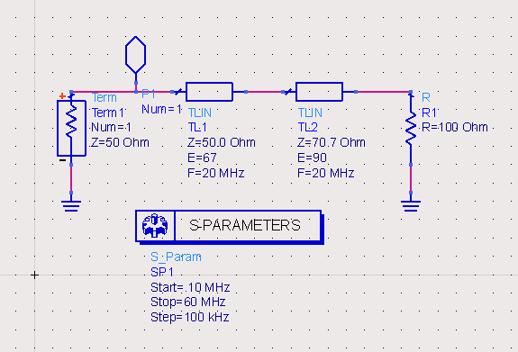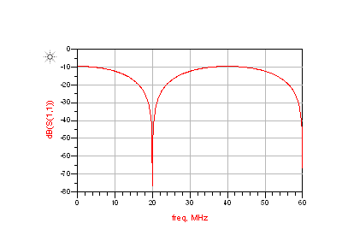

2.

$$Z_{in}= Z_{O1}(\frac{z_{L}\cos\left(βl\right)+jsin\left(βl\right)}{\cos\left(βl\right)+jz_{L}\sin\left(βl\right)})$$

Equation 1

$$Γ_{L}= \frac{R_{L}-Z_{O2}}{R_{L}+Z_{O2}}$$

Equation 2

$$Γ_{in}= Γ_{L}e^{-j2βl}$$

Equation 3

|  |  |  |
| --- | --- | --- |
|  | 20 MHz | 40 MHz |
| E (radians) | π/2 | 134π/180 |
| Zin (Ohms) | 49.9849 | 100 |
| ΓL | -1.51 * 10-4 | 1/3 |
| Γin | 1.0491 * 10-4 + j1.086 * 10-4 | -1.163 * 10-2 + j.33313 |

3. This system represents a ¼ wavelength transformer. The second TLine has parameters such that it appears to be 50 ohms where it joins the first TLine, so it impedance matches the first TLine at 50 Ohms.

**Additional ADS Exercises**

1.

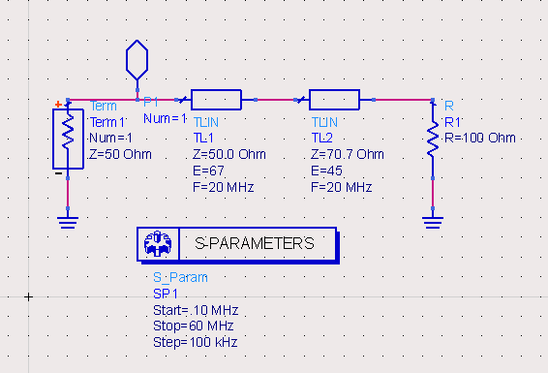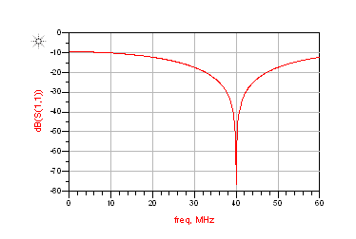

The line has a minimum at 40MHz because it has 1/8 wavelength at 20 MHz. So at 40 MHz it is like a ¼ wavelength system matching the first T-Line again with 50 Ohms. The peak is at 80 MHz, which is because the wavelength is twice that of the first exercise which makes the distance between the peaks (or valleys) 80MHz or half of a wavelength.

2. **Creative exercise:**

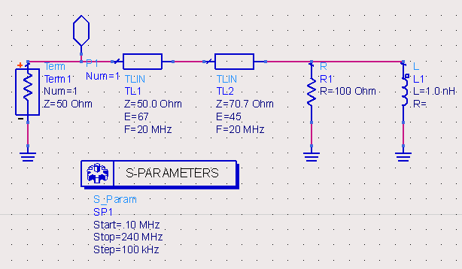 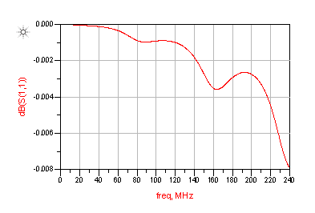

I added an inductor to the load to get a cool frequency response curve. The attenuation decays in an odd fashion because the inductor resists change in current, so as the voltage changes it tries to resist it, which is why the waveform decreases and then steadies, and decreases, and then increases and then drops to 0. It starts acting like an open circuit and ends up acting like a short. The inductor has an impedance that changes with frequency at jwL.